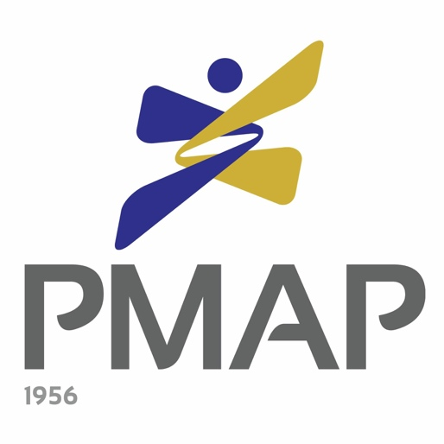

_______________________________________________________________________________

43rd PMAP Awards

Nomination Form
EMPLOYER OF THE YEAR AWARD

_______________________________________________________________________________

People Management Association of the Philippines (PMAP)

The People Management Association of the Philippines (PMAP) is a strictly professional, non-stock, not-for-profit organization of over 1,300 companies and individual management executives engaged or interested in human resource management and industrial relations work. Founded in 1956, PMAP continues the tradition of its forefathers in advancing the profession, the science and the art of human resource management.

As a professional association, PMAP helps institutions mold an enlightened, competent, socially responsible and influential sector of people managers who effectively participate in nation building. PMAP also helps its members become more effective on the job by teaching the human aspect of management via career development forums and training programs.

With 27 chapters throughout the Philippines, PMAP encourages local participation if national affiliation is geographically difficult. In fact, what further enhances PMAP’s solid reputation as a national association is the dynamism of its local chapters.

_______________________________________________________________________

The PMAP Awards

The PMAP Awards were institutionalized in 1977 with the vision to recognize outstanding organizations and individuals to help advance the people management profession in the country.

There are three categories for the PMAP Awards - Employer of the Year, People Manager of the Year and the People Program of the Year. These awards may be vied for by organizations and individuals in both the private and public sectors.
The PMAP Awards program has achieved a number of milestones since its institution. In 2011, the first Employer of the Year for Small and Medium Enterprises was awarded. In 2014, the PMAP Awards started recognizing outstanding organizations and individuals in the public/government sector. In 2016, the PMAP Awards formally introduced its own criteria for the Employer of the Year and People Program of the Year Awards. This criteria is based on the People Management Excellence Framework, a product of an in-depth analysis of practices and characteristics of past Employer of the Year awardees and was written by PMAP Past President Mr. Enrique V. Abadesco, DPM.

People Management Association of the Philippines (PMAP)

The People Management Association of the Philippines (PMAP) is a strictly professional, non-stock, not-for-profit organization of over 1,300 companies and individual management executives engaged or interested in human resource management and industrial relations work. Founded in 1956, PMAP continues the tradition of its forefathers in advancing the profession, the science and the art of human resource management.

As a professional association, PMAP helps institutions mold an enlightened, competent, socially responsible and influential sector of people managers who effectively participate in nation building. PMAP also helps its members become more effective on the job by teaching the human aspect of management via career development forums and training programs.

With 29 chapters throughout the Philippines, PMAP encourages local participation if national affiliation is geographically difficult. In fact, what further enhances PMAP’s solid reputation as a national association is the dynamism of its local chapters.

__________________________________________________________________________________

The PMAP Awards

The PMAP Awards program was institutionalized in 1977 with the vision to recognize outstanding organizations and individuals to help advance the people management profession in the country.

There are three categories for the PMAP Awards - Employer of the Year, People Manager of the Year and People Program of the Year. These awards may be vied for by organizations and individuals in both the private and public sectors.
The PMAP Awards program has achieved a number of milestones since its institution. In 2011, the first Employer of the Year for Small and Medium Enterprises was awarded. In 2014, the PMAP Awards started recognizing outstanding organizations and individuals in the public/government sector. In 2016, the PMAP Awards formally introduced its own criteria for the Employer of the Year and People Program of the Year Awards. This criteria is based on the People Management Excellence Framework, a product of an in-depth analysis of practices and characteristics of past Employer of the Year awardees and was written by PMAP Past President Mr. Enrique V. Abadesco, DPM.

Starting 2017, the PMAP Awards not only recognized the winners of the three categories but the finalists as well through the PMAP Exemplar Award. This award recognizes their outstanding contributions and best practices in human resource management.

Now on its 43rd year, the PMAP Awards program hopes to continue this tradition of recognizing the best practices in the people management field for others to emulate. The program also hopes to expand its reach through the regional awards search approach.

__________________________________________________________________________________

43rd PMAP Awards Process
The PMAP Awards program undergoes a rigorous search process every year. It starts with receiving nomination forms from various organizations and individuals and these nominees are then requested to submit data forms/write ups should they be interested to vie for any of the awards. The Awards Committee, composed of seasoned HR practitioners, then reviews the submitted documents and conducts site visits to all of the qualified nominees. During these site visits, the Awards Committee interviews employees from all levels of the organization, starting from the top management down to the rank and file employees. After conducting site visits for all nominees, the Awards Committee will come up with a shortlist of finalists who will be endorsed to the Board of Judges, who will then select the winner/s after they conduct their own site visits and validation interviews. The national winners will then be formally announced during the 43rd PMAP Awards Night during the 56th PMAP Annual Conference.

This 2019, the search process for the PMAP Awards will be as follows:

In the previous years, the Awards search process was not segmented per geographic region. In order to promote a national advocacy of excellence in people management and actively engage our 29 PMAP chapters, the PMAP Awards started recognizing regional winners in 2018.

Through this process, there will be Employer, People Manager, and People Program of the Year winners from the following regional areas:
- NCR
- Luzon
- Visayas
- Mindanao

Later on, these regional winners will become the finalists for the national Employer of the Year, People Manager of the Year and People Program of the Year awards which will be chosen by a Board of Judges.

Employer of the Year Award (EOY)

The Employer of the Year (EOY) Award aims to give recognition to a company that satisfactorily fulfills its people management responsibilities, as demonstrated by its leadership, dynamism, professionalism, strategic thinking and implementation, continuous improvement in HR processes and programs, linkage of HR to business objectives, and employee focus.

This award is meant to give public honor to the company for others to emulate its example.

The criteria for the award is adopted from the People Management Excellence Framework crafted by PMAP Past President Enrique V. Abadesco, DPM.

Criteria for the Award

- Line Management & HR Partnership (25%)
The driving attribute of a high performing people-focused organization is the partnership between HR and line management. Senior leaders clearly articulate their belief that people are a key factor for business success and visibly demonstrate valuing people through HR programs of the company. HR is considered a strategic player and is credible to the operating managers who champion HR programs and take the lead in engaging their people.

2. Performance Focus (25%)
A key success factor among high performing organizations is their sharp focus on performance and results. In the private sector, profitability and business growth are key indicators of results. In the public sector, efficient and responsive service delivery to the citizenry are targeted results. Clear directions, strategies and values send strong signals for performance and help create a results-oriented culture. Plans and programs are well-deployed throughout the organization, systematically tracked at the unit and individual levels

3. Leadership Approaches (20%)
Excellent organizations institute and adopt programs and initiatives characterized as transformative, innovative and systematic. They are constantly trying to adapt to the changing challenges of their external environments, hence the presence of an open, change-friendly and continuous improvement mindset. The leadership style of the leaders at all levels of the organization can be described as coaching, inspiring, and people engaging.

4. People Engagement (20%)
High performing and people-focused organizations tap the full potential of their workforce. They have multiple programs of eliciting employee participation and engagement, attend to their learning and development needs and systematically pay attention to their engagement levels and well-being needs.

5. Social Responsibility (5%)
A key responsibility given high importance to by excellent organizations is good citizenship, community relations and environmental protection. This attribute also covers business ethics, the protection of public health and safety, the promotion of volunteerism and the sharing of best practices. Social responsibility also looks into the advocacy practices such as equal opportunity and inclusion and diversity as well as compliance to labor standards and government regulations.

6. HR Competence and Credibility (5%)
A pre-condition of the first attribute (line management and HR partnership) is the HR unit’s competence and credibility. Credibility comes from the HR practitioners’ personal values and professional maturity while competence comes from their conceptual, business, and HR functional expertise.

Rules for the Award (EOY)

1) Nominations are open to all companies nationwide including non-PMAP corporate/chapter members.
2) Nominations shall be endorsed by either a PMAP member of good standing or by a member of any nationally-recognized organization (such as the Jaycees, Rotary Club, Kiwanis, Lions, PCCI, ECOP, Industry and Functional Groups, etc.). Self-nomination is also allowed.
3) Previous Employer of the Year nominees may again be nominated for the same category provided there is a two (2)-year gap between the date of the last nomination (e.g. companies that vied for the award in 2016 may only be nominated again in 2019).
4) Previous Employer of the Year winners may again be nominated for the same category provided there is a five (5)-year gap between the date of the last award and the date for this year’s nomination.
5) The accomplished Nomination Form must be received by the Awards Committee on or before 31 January 2019. All nominations will be screened by the PMAP Awards Committee. All eligible nominees will be notified and then requested to submit the Data Form. The EOY Data Form can be downloaded at www.pmap-awards.org.
6) The PMAP Award Committee reserves the right to validate all claims officially presented by the nominees.
7) The Board of Judges composed of distinguished men and women representing various sectors/industries will deliberate on the merits of each of the nomination and select the final winners of the awards.
8) Should there be inconsistencies established which may materially affect the integrity of the nomination due notice of the appropriate action to be taken by the committee shall be sent to the contact person.
9) The PMAP Board of Trustees shall confirm the decision of the Board of Judges, which shall be final and unappealable.
10) The Awards Committee, Board of Judges and PMAP Board of Trustees will not entertain or answer any requests for clarification from non-winners.
11) Regional winners will be recognized during the respective PMAP regional summits. The national winners will only be revealed during the 43rd PMAP Awards Night during the 56th PMAP Annual Conference.
12) Specific branch/plant operations may vie as a single entry for the specific regional area that they belong to, for as long as they have their own branch/plant-based leadership team (who perform the functions of human resources, operations, and finance) and the head office will not vie for the same category.

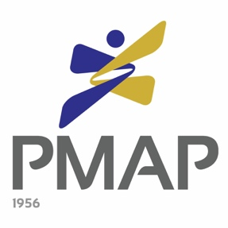

43rd PMAP Awards

EMPLOYER OF THE YEAR AWARD

OFFICIAL NOMINATION FORM

Date: ___________________

To the 2019 PMAP Awards Committee,

I am pleased to nominate for the 2019 PMAP Employer of the Year Award:

Name of Company: _______________________________________________________
Address: _________________________________________________________________

_________________________________ ___________________________________
Printed Name & Signature of Nominator Company of Nominator

_______________________________________________________________________________
Address and Contact Number of Nominator

Nomination forms may be submitted to PMAP through:

- Sealed envelope sent to PMAP Awards Committee, 670 Lee St., Addition Hills, Mandaluyong City or
- Scanned copy sent to pmap@pmap.org.ph (cc: issa.nery@pmap.org.ph)

For inquiries, contact the PMAP Awards Committee through
Tel. No: 726-1532 | Fax No.: 726-1530
Email: issa.nery@pmap.org.ph

DEADLINE FOR NOMINATIONS IS ON JANUARY 31, 2019.

