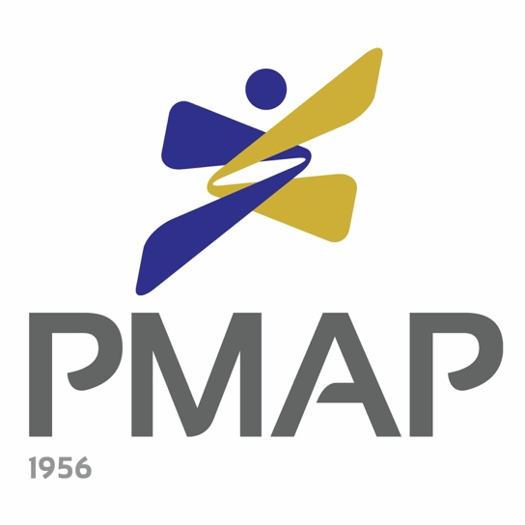

_______________________________________________________________________________

43rd PMAP Awards

Nomination Form
PEOPLE MANAGER OF THE YEAR AWARD

______________________________________________________________________________

People Management Association of the Philippines (PMAP)

The People Management Association of the Philippines (PMAP) is a strictly professional, non-stock, not-for-profit organization of over 1,300 companies and individual management executives engaged or interested in human resource management and industrial relations work. Founded in 1956, PMAP continues the tradition of its forefathers in advancing the profession, the science and the art of human resource management.

As a professional association, PMAP helps institutions mold an enlightened, competent, socially responsible and influential sector of people managers who effectively participate in nation building. PMAP also helps its members become more effective on the job by teaching the human aspect of management via career development forums and training programs.

With 29 chapters throughout the Philippines, PMAP encourages local participation if national affiliation is geographically difficult. In fact, what further enhances PMAP’s solid reputation as a national association is the dynamism of its local chapters.

_______________________________________________________________________________

The PMAP Awards

The PMAP Awards program was institutionalized in 1977 with the vision to recognize outstanding organizations and individuals to help advance the people management profession in the country.

There are three categories for the PMAP Awards - Employer of the Year, People Manager of the Year and People Program of the Year. These awards may be vied for by organizations and individuals in both the private and public sectors.
The PMAP Awards program has achieved a number of milestones since its institution. In 2011, the first Employer of the Year for Small and Medium Enterprises was awarded. In 2014, the PMAP Awards started recognizing outstanding organizations and individuals in the public/government sector. In 2016, the PMAP Awards formally introduced its own criteria for the Employer of the Year and People Program of the Year Awards. This criteria is based on the People Management Excellence Framework, a product of an in-depth analysis of practices and characteristics of past Employer of the Year awardees and was written by PMAP Past President Mr. Enrique V. Abadesco, DPM.

Starting 2017, the PMAP Awards not only recognized the winners of the three categories but the finalists as well through the PMAP Exemplar Award. This award recognizes their outstanding contributions and best practices in human resource management.

Now on its 43rd year, the PMAP Awards program hopes to continue this tradition of recognizing the best practices in the people management field for others to emulate. The program also hopes to expand its reach through the regional awards search approach.

_______________________________________________________________________________

43rd PMAP Awards Process
The PMAP Awards program undergoes a rigorous search process every year. It starts with receiving nomination forms from various organizations and individuals and these nominees are then requested to submit data forms/write ups should they be interested to vie for any of the awards. The Awards Committee, composed of seasoned HR practitioners, then reviews the submitted documents and conducts site visits to all of the qualified nominees. During these site visits, the Awards Committee interviews employees from all levels of the organization, starting from the top management down to the rank and file employees. After conducting site visits for all nominees, the Awards Committee will come up with a shortlist of finalists who will be endorsed to the Board of Judges, who will then select the winner/s after they conduct their own site visits and validation interviews. The national winners will then be formally announced during the 43rd PMAP Awards Night during the 56th PMAP Annual Conference.

This 2019, the search process for the PMAP Awards will be as follows:

In the previous years, the Awards search process was not segmented per geographic region. In order to promote a national advocacy of excellence in people management and actively engage our 29 PMAP chapters, the PMAP Awards started recognizing regional winners in 2018.

Through this process, there will be Employer, People Manager, and People Program of the Year winners from the following regional areas:
- NCR
- Luzon
- Visayas
- Mindanao

Later on, these regional winners will become the finalists for the national Employer of the Year, People Manager of the Year and People Program of the Year awards which will be chosen by a Board of Judges.

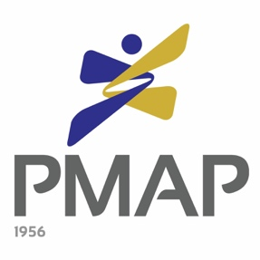

43rd PMAP Awards

PEOPLE MANAGER OF THE YEAR AWARD

OFFICIAL NOMINATION FORM

Date: ___________________

To the 2019 PMAP Awards Committee,

I am pleased to nominate for the 2019 PMAP People Manager of the Year Award:

Full Name of Nominee: ____________________________________________________
Company: ________________________________________________________________
Address: _________________________________________________________________

_________________________________ ___________________________________
Printed Name & Signature of Nominator Company of Nominator

_______________________________________________________________________________
Address and Contact Number of Nominator

Nomination forms may be submitted to PMAP through:

- Sealed envelope sent to PMAP Awards Committee, 670 Lee St., Addition Hills, Mandaluyong City
- Scanned copy sent to pmap@pmap.org.ph (cc: issa.nery@pmap.org.ph)

For inquiries, contact the PMAP Awards Committee through
Tel. No: 726-1532 | Fax No.: 726-1530
Email: issa.nery@pmap.org.ph

DEADLINE FOR NOMINATIONS IS ON JANUARY 31, 2019

